## Research: plastic recyling

* India generates close to 26,000 tonnes of plastic a day, according to a CPCB estimate from 2012. Worse, a little over 10,000 tonnes a day of plastic waste remains uncollected.
* As of 2015, around 30% of all the plastic waste ever generated had been recycled
* people usually throw it here and there or toss it into the trash can thinking it will go into a recycling bin and they did out bid to save the earth. Well, the fate of the items we throw out is far from certain.
* When you are banning plastic, you are not taking into account the entire scenario that has to change with it. So instead of closing down plastic manufacturing and trading units and rendering lakhs jobless, govt should be nudged to produce alternatives. Banning is surely not the solution in fact it yields to other problems which can certainly not be ignored, take for instance Maharashtra where, plastic ban costed 3 lakh jobs, loss of Rs 15,000 crores.
* Explain Our idea : Basically to collect clean bottles and efficiently make them reach the recycling centres, such that the customers and the distributors get a fair amount of money in the form of reward points. Explain qr code and bar code
* Funding and paisa kaha se ayega:-
* Manufacturing cost and selling price of a plastic bottle
* 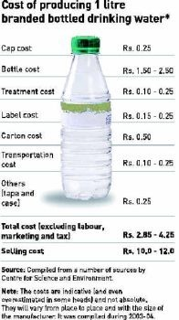 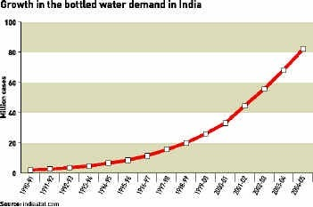
* A person connected to the field said the total manufacturing cost of 200ml Coke is RS.1.10. Rupee one and paise ten. Any breakages of bottle at point of sales has to borne by the retailer. Including transport and dealer commission they must be getting RS 7/- as profit.
* Recycling ease and prices :-
* 